React
React is a JavaScript library for building user interfaces (UIs), specifically single-page applications. It allows developers to create reusable UI components, making it easier to manage complex interfaces and improve code efficiency.

Key Concepts
- Components: React applications are built from small, self-contained pieces of code called components. Each component is responsible for rendering a specific part of the UI. For example, a button, a navigation bar, or an entire page could be a component.
- Virtual DOM: React uses a Virtual Document Object Model (DOM), which is a lightweight copy of the actual DOM. When data changes, React first updates the virtual DOM, then efficiently calculates the minimum changes needed to update the real DOM. This process, known as reconciliation, significantly improves performance.
- Declarative Syntax: React uses a declarative approach. Instead of telling the application how to change the UI, you describe what the UI should look like for a given state. React then handles updating the UI to match that description.
- JSX: JSX (JavaScript XML) is a syntax extension for JavaScript used with React. It looks like HTML but allows you to write HTML-like elements directly within your JavaScript code, making it more intuitive to define UI structure.

How it Works
React follows a unidirectional data flow, meaning data flows in one direction from a parent component to its child components through props (short for properties). When a component's internal state changes, React re-renders the component and its children to reflect the new state. This predictable flow makes debugging and understanding the application's behavior much simpler.

featured on react 19
A major highlight is the React Compiler, which automatically optimizes your code by automatically handling memoization. This means you no longer have to manually use hooks like useMemo, useCallback, and memo to prevent unnecessary re-renders.
Another key feature is Actions, which simplifies form handling and data mutations. Actions are functions that can be executed on either the client or the server side, allowing for a more straightforward way to manage form submissions and state updates without boilerplate code. This is complemented by new hooks like useActionState, useFormStatus, and useOptimistic, which help manage form state, pending states, and provide immediate, optimistic UI feedback.
Additional new features and improvements include:
- Server Components: This feature, which can be run at build time or on a web server, helps to improve initial page load times and SEO by reducing the amount of JavaScript sent to the client.
- The use() Hook: This new, versatile hook simplifies data fetching and consuming context by allowing you to read the value of a promise or context directly within your component's render function, even inside conditional statements or loops.
- Web Components Support: React 19 improves compatibility with web components, making it easier to integrate them into your projects.
- Document Metadata: You can now natively render document metadata tags like <title> and <meta> within your components, simplifying SEO management.

Hook
A Hook is a special function in React that lets you "hook into" React features from a functional component. Before hooks, these features (like state and lifecycle methods) were only available in class components. Hooks allow you to write components with state and other features without using classes.

Rules of Hooks
There are two primary rules you must follow when using hooks:
- Only Call Hooks at the Top Level: You should only call hooks at the top level of your React function. This means you cannot call hooks inside loops, conditional statements (if), or nested functions. This ensures that hooks are called in the same order every time the component renders, which is how React correctly associates state with the corresponding hook calls.
- Only Call Hooks from React Functions: You can only call hooks from React functional components or from custom hooks. You cannot call them from regular JavaScript functions. This rule ensures that the logic of your hooks is tied to the lifecycle of a React component.

useState
useState is a React Hook that allows you to add a state variable to a functional component. It's the most fundamental hook for managing a component's internal data that needs to be tracked and updated.
It returns an array with two elements:
- The current state value.
- A setter function to update that value.
When you call the setter function, React will re-render the component with the new state.
Here, count is the state variable, initialized to 0, and setCount is the function used to update it.
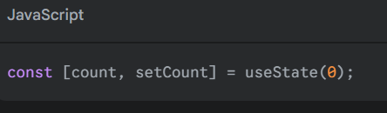

useEffect
useEffect is a Hook that lets you perform side effects in a functional component. Side effects are operations that interact with the outside world, like fetching data from an API, setting up subscriptions, or manually manipulating the DOM.
It takes two arguments:
- A function containing the side effect logic.
- An optional dependency array.
React will run the effect function after every render by default. By providing a dependency array, you can tell React to only re-run the effect when the values in that array have changed. An empty array ([]) means the effect will run only once, after the initial render.
Example:
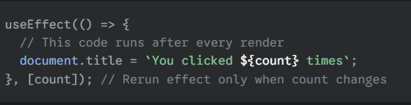
useRef
useRef is a Hook that allows you to create a mutable object that persists for the entire lifetime of a component. It's commonly used to access and interact with a DOM element directly, but it can also be used to store any value that needs to be preserved across re-renders without causing the component to update.
It returns a single object with a property called .current, which you can set or update. Changes to a ref do not trigger a component re-render.
Example:
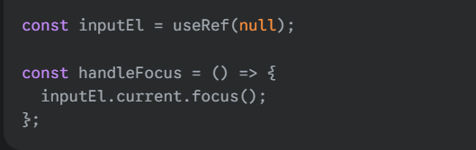

Here, useRef creates a ref object to hold a reference to an HTML input element, allowing a function to programmatically focus it.

library vs framework
A library is a collection of reusable code (functions, classes, etc.) that you can call from your own code to perform specific tasks. You are in control of the application's flow, and you decide when and where to use the library's functions. Think of a library as a toolbox—you pick out the specific tool (function) you need, when you need it, and use it within your own project.
A framework is a more comprehensive structure that provides the foundation for an entire application. It defines the flow and architecture, telling you where to place your code and what conventions to follow. With a framework, the framework is in control; it calls your code when it's needed. Think of a framework as a house blueprint—it dictates the layout, and you just fill in the rooms with your own code.

Single Page Application (SPA)
1. We want to build a Single Page Application (SPA) to give users a fast, fluid experience without full-page reloads.
2. But updating the Real DOM directly to change the content is slow and inefficient.
3. So, React uses a Virtual DOM —a lightweight blueprint—to plan out changes in memory first.
4. It uses Diffing to compare the old and new blueprints to find the absolute minimum changes needed.
5. The process of applying those minimal changes to the Real DOM is called Reconciliation.
6. Finally, React Fiber is the modern engine that performs this reconciliation, with the crucial ability to pause and prioritize work, ensuring high-priority user interactions are always handled first.

Key Differences Between JSX and HTML
Since JSX is fundamentally JavaScript, some HTML attributes have different names to avoid conflicting with reserved JavaScript keywords.

className vs. class: This is the most common one. Because class is a reserved word in JavaScript (for creating classes), React uses className instead.

CamelCase for Attributes: HTML attributes with a dash (like onclick or tabindex) are written in camelCase in JSX (like onClick or tabIndex).

JavaScript Expressions: You can embed any JavaScript expression directly inside JSX by wrapping it in curly braces {}.
For example: <h1>{user.name}</h1> or <p>2 + 2 = {2 + 2}</p>.

Self-Closing Tags: Tags that are self-closing in HTML, like <br> or <img>, must be explicitly closed in JSX with a slash: <br /> or <img />.

Rules of JSX
Think of these as the grammar for this special syntax. There are two main rules you'll always need to follow.

1. Components Must Return a Single Root Element
A component can only return one top-level element. If you want to return multiple elements, you must wrap them in a single parent tag, like a <div> or a special, invisible wrapper called a Fragment (<>...</>).

return (
<>
<h1>About Us</h1>
<p>We are a React learning team!</p>
</>
)

2. You Must Close All Tags
In HTML, some tags like <br> or <img> don't need a closing tag. In JSX, every tag must be closed, either with a separate closing tag (<div></div>) or by self-closing with a / at the end (<img />).

React without JSX

Without JSX, you would have to write the exact same thing using React's built-in createElement function, which looks like this:

const element = React.createElement(
'h1',
{className: 'greeting'},
'Hello, world!'
);

Bundlers: Webpack and Vite
When you build a large application, your code is split into many different files or "modules". You also use code from third-party packages. A module bundler is a tool that takes all these separate files and dependencies and bundles them into a few optimized files (usually one main JavaScript file and one CSS file) that the browser can download efficiently.

Webpack: For a long time, Webpack was the most popular and powerful bundler. It's highly configurable and has a massive ecosystem of plugins. However, for large projects, it can become slow, especially during development, because it has to re-bundle a lot of code every time you make a change.

Pros of Vite
The main advantages of Vite are its speed and simpler developer experience:

Extremely Fast Dev Server: Starts almost instantly, regardless of project size.

Hot Module Replacement (HMR): Updates are reflected in the browser almost instantaneously without losing the application's state.

Simpler Configuration: Often requires little to no configuration to get started.

Optimized Build: For production, it uses a highly optimized bundler (Rollup) to create a small and efficient bundle.

How SPAs Load Dynamic Data
A Single Page Application (SPA) feels fast because it updates content without a full page reload. It does this by fetching only the data it needs from a server.

The most common way this happens is through an API (Application Programming Interface) call.

User Action: The user clicks a button or loads a page (e.g., clicking on a user's profile).

API Request: The React application, running in the browser, sends a request to a server. This is typically done using the browser's fetch function or a library like axios. The request asks for specific data, like the profile information for "user123".

Server Response: The server receives the request, gets the data from a database, and sends it back, usually in a structured format called JSON (JavaScript Object Notation).

State Update: The React app receives the JSON data and updates its state (e.g., using the useState hook) with the new information.

Re-render: React detects the state change and automatically re-renders only the components that need the new data, updating the screen dynamically.

In short, SPAs replace the old "request a whole new page" model with a "request just the data you need" model.

htmlFor Attribute
This is another specific rule of JSX, similar to className.

In standard HTML, you use the for attribute on a <label> to link it to a form input.

<label for="username">Username:</label>
<input id="username" type="text" />
However, in JavaScript, for is a reserved keyword used for for loops. Because JSX is JavaScript, you must use the camelCase version instead: htmlFor.

<label htmlFor="username">Username:</label>
<input id="username" type="text" />

Transpilation and Babel
Modern JavaScript has many new features that older web browsers don't understand. Similarly, browsers don't understand JSX at all.

Transpilation is the process of taking modern JavaScript and JSX and converting it into older, more compatible JavaScript that can run in any browser. It's like translating a text from a modern dialect into a classic one that everyone can read.

The most popular tool for this job is Babel. When you write React code with JSX and modern syntax, Babel works behind the scenes to transpile it into plain JavaScript that browsers can execute.

Bundlers: Webpack and Vite
When you build a large application, your code is split into many different files or "modules". You also use code from third-party packages. A module bundler is a tool that takes all these separate files and dependencies and bundles them into a few optimized files (usually one main JavaScript file and one CSS file) that the browser can download efficiently.

Webpack: For a long time, Webpack was the most popular and powerful bundler. It's highly configurable and has a massive ecosystem of plugins. However, for large projects, it can become slow, especially during development, because it has to re-bundle a lot of code every time you make a change.

Vite: Vite is a modern and much faster alternative to Webpack. Instead of re-bundling all the code on every change, Vite uses modern browser features (Native ES Modules) to serve files directly to the browser during development. It only transforms and serves the code you are actually requesting. This makes its development server start instantly and updates happen almost immediately.

NPM and Package Files
npm (Node Package Manager): This is the default package manager for the JavaScript ecosystem. It's a command-line tool that allows you to install and manage third-party packages (libraries and tools) in your project. When you run npm install react, npm downloads the React package from a central registry and puts it in a folder called node_modules in your project.

package.json vs. package-lock.json: These two files are created to manage your project's dependencies.

package.json: This file lists your project's dependencies and their version ranges (e.g., "I need React version 18.2.0 or newer"). It also contains other metadata about your project, like its name and scripts. You edit this file.

package-lock.json: This file is automatically generated by npm. It records the exact version of every single package that was installed. This ensures that every developer on your team, and your production server, uses the exact same versions of all dependencies, preventing "it works on my machine" problems. You should not edit this file directly.

ES Modules
In modern JavaScript, code is organized into modules, which are just individual files. This allows you to split your code into reusable, organized pieces. To use code from one module in another, you use import and export statements.

There are two main types of exports:

Named Export: You can export multiple values from a single file. When you import them, you must use the exact same names inside curly braces.

// utils.js
export const PI = 3.14;
export const greet = () => "Hello!";

// app.js
import { PI, greet } from './utils.js';

Default Export: You can export only one "main" value from a file. When you import a default export, you can give it any name you want, and you don't use curly braces.

JavaScript

// Button.js
export default function Button() {
// ... button component code
}

// app.js
import MyCoolButton from './Button.js'; // Can be named anything

Regarding Named Exports without Curly Braces: In the standard ES Module system, you must use curly braces to import named exports. The syntax is a core part of how JavaScript distinguishes between named and default imports

<span> Tag
The <span> tag is an inline HTML element used to group inline-elements for styling purposes. Unlike a <div> tag, which is a block-level element and creates a line break, a <span> does not. It's often used to apply styles like color, font size, or background color to a specific piece of text within a larger block of text.

Example:
<p>My mother has <span style="color:blue; font-weight:bold;">blue</span> eyes.</p>
In this sentence, only the word "blue" will be bold and colored blue, without disrupting the flow of the paragraph.

Viewport
The viewport is the user's visible area of a web page. It varies depending on the device used to view the site—it will be smaller on a mobile phone than on a computer screen.

To create responsive websites that look good on all devices, web developers use the viewport meta tag in their HTML's <head> section:

<meta name="viewport" content="width=device-width, initial-scale=1.0">
This tag tells the browser to set the width of the page to the screen-width of the device and to set the initial zoom level to 100%. This is essential for modern, responsive design.

Why console.log in App.jsx Appears Twice
This happens because of React.StrictMode.

StrictMode is a tool for highlighting potential problems in an application. To help you find bugs related to "impure" functions and side effects, it intentionally renders components twice in development mode. This double-rendering helps ensure your components behave predictably.

This behavior only occurs in development and will not happen in the final production build that your users see.

Shadow DOM
The Shadow DOM is a browser technology, completely separate from React's Virtual DOM. It allows you to encapsulate a part of the DOM, keeping its styles and scripts isolated from the rest of the page.

Think of it as a "DOM within a DOM." The styles you write inside a shadow DOM won't leak out and affect other parts of the page, and global styles won't break the components inside. This is how the browser creates complex elements like the <video> tag with its own play button and volume slider—those controls live in a shadow DOM.

Shadow DOM: A browser feature for encapsulation and style isolation.
Virtual DOM: A React concept (a JavaScript object) for performance and efficient re-renderin

Root DOM Element
The root DOM element is the single HTML element on your webpage inside which your entire React application is mounted and rendered. By convention, this is usually an empty <div> with an ID of root.

Think of it as the foundation of a house. Your index.html file provides the empty plot of land with the foundation laid, and React builds the entire house inside it.

ReactDOM.createRoot
ReactDOM.createRoot is the modern React function used to initialize your application. It tells React which DOM element will be the "root" for your app and enables React's concurrent features, which help keep your app responsive.

You pass the root DOM element to this function, and it returns a root object. You then call the .render() method on this object to display your main component (e.g., <App />).

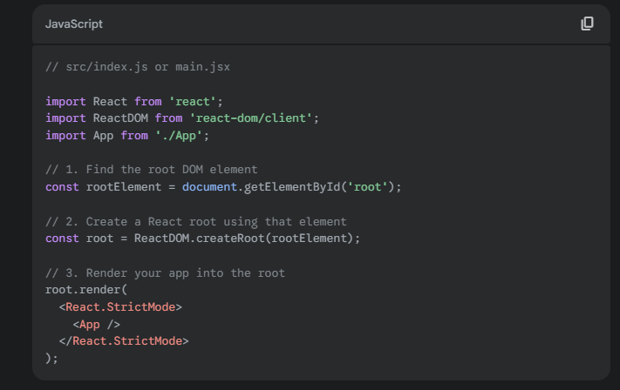

Can We Use Named Exports Without {}?
No. You must use curly braces {} to import a named export.

The syntax is designed to be explicit:

import { myValue } from './file';: This tells JavaScript you are specifically looking for an export named myValue.

import myValue from './file';: This tells JavaScript you are importing the one and only default
export from that file.

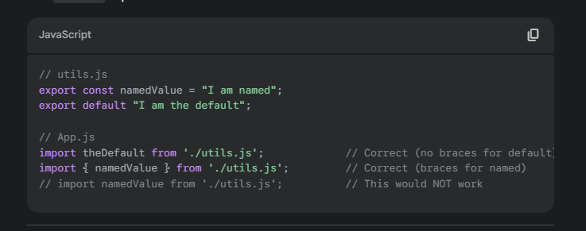
.

Integrating React into an Existing Application
You don't need to build a full SPA to use React. You can easily integrate React components into specific parts of any existing static or server-rendered website.

Here’s the basic approach:

Add Scripts: In your existing HTML file, add CDN links for React, ReactDOM, and a transpiler like Babel (to handle JSX).

Define a Root Element: Add a <div> with a unique ID where you want your React component to appear.

Write and Render: Add a <script type="text/babel"> tag. Inside it, define your React component and then use ReactDOM.createRoot to render it into the div you created.

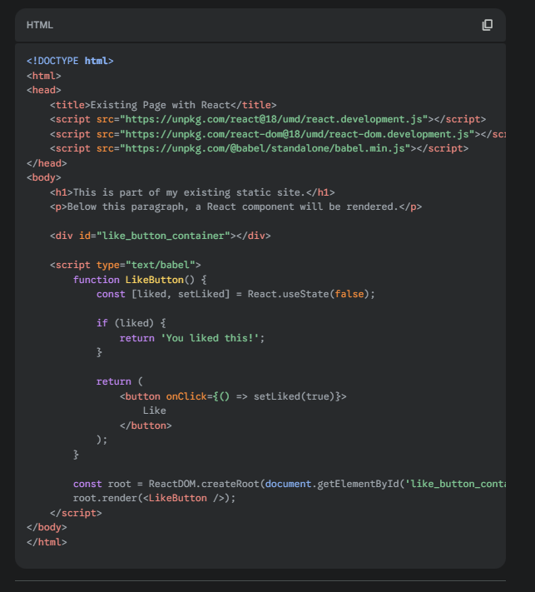

New Features of React 19
React 19, which became generally available in August 2025, introduces several powerful features focused on performance and developer experience.

React Compiler: This is the biggest feature. It's an optimizing compiler that automatically converts your React code into highly optimized JavaScript. It eliminates the need for manual memoization with useMemo, useCallback, and React.memo, simplifying your code while making it faster by default.

Actions: A new, integrated way to handle data mutations, like form submissions. Actions automatically manage pending, error, and optimistic update states, making your data-handling logic much cleaner. New hooks like useActionState and useFormStatus support this.

Server Components: While introduced earlier, they are now a stable and core part of React. They allow you to write components that run exclusively on the server, reducing the amount of JavaScript sent to the client.

Enhanced Asset Loading: React 19 provides better support for preloading assets like stylesheets, fonts, and scripts, which helps prevent flickering as new content loads.

Web Components: Improved support for using Web Components (which often use the Shadow DOM) within your React applications.

Component Definition
A component is the fundamental building block of a React application. It's a reusable, self-contained piece of UI (User Interface). Think of a webpage as being made of Lego bricks—each brick (a button, a search bar, a user profile) is a component.

Components can be simple, like a single button, or complex, like an entire page composed of many smaller components. The main idea is to split the UI into independent pieces that can be developed and managed separately.

Component Lifecycle
Every React component has a "lifecycle," which is a series of phases it goes through from its creation to its destruction. Understanding this lifecycle is crucial for performing actions at specific moments, like fetching data when the component first appears or cleaning up when it's removed.

The three main phases are:

Mounting: The component is being created and inserted into the DOM for the first time.

Updating: The component is re-rendering because its props or state have changed.

Unmounting: The component is being removed from the DOM.

Lifecycle Methods in Class Components
Class components use special methods that are automatically called during these lifecycle phases.

Mounting Phase
constructor(): Called first to set up initial state.

render(): Renders the UI.

componentDidMount(): Called immediately after the component is rendered to the DOM. This is the perfect place to perform actions that need a DOM to exist, like fetching data from an API.

Updating Phase
render(): Re-renders the UI with the new data.

componentDidUpdate(): Called immediately after an update occurs. This is where you can perform side effects based on the new props or state, like making another API call if a user ID prop changes.

Unmounting Phase
componentWillUnmount(): Called right before the component is removed from the DOM. This is the place to do any necessary cleanup, such as canceling network requests or removing event listeners to prevent memory leaks.

Stateful vs. Stateless Components
This is a way to classify components based on whether they manage their own data.

Stateful Components: These components have their own internal state, which they can read and update. This is like a component having its own personal memory. Because a stateful component can change its own data, it can also cause itself to re-render in response to user actions or other events. They are essential for building interactive and dynamic UIs. In React, you create a stateful component using the useState or useReducer Hooks.
Stateless Components: These components are simpler and do not have their own state. They only receive data from their parent components through props. They are often called "pure" components because for a given set of props, they will always render the exact same output. Stateless components are ideal for presenting data and building static parts of a UI. Most simple, presentational functional components are stateless.

pure component
A pure component is a type of component that will always render the exact same output, as long as it receives the same props and state. They don't have side effects, like network requests or subscriptions, that would cause different behavior.
In other words, a pure component's output is solely determined by its inputs (props and state). This predictability makes them easier to test and can lead to performance optimizations, as the rendering process can be skipped if the inputs haven't changed.
In React, pure components are implemented differently for class and functional components:
- Class Components: You can create a pure class component by extending React.PureComponent instead of React.Component. This automatically implements a shallow comparison of props and state to decide whether to re-render.
- Functional Components: Functional components are often pure by nature. You can explicitly make a functional component pure by wrapping it in React.memo. This memoizes the component's output and prevents re-renders unless its props have changed

State vs. Props:
State and props are both plain JavaScript objects that store data that influences a component's rendering. However, they are fundamentally different in how they're used and managed within a component-based architecture like React.
State
State is a component's private, internal memory . It holds data that is expected to change over time, often as a result of user interactions, network requests, or other events. Because state is managed internally, a component has the ability to both read and update its own state. When the state changes, the component will re-render to reflect the new data. For example, a counter component's state might hold the current count, which increments when a button is clicked.
- Managed by: The component itself.
- Mutability: It is mutable, meaning it can be changed. However, you should never modify state directly (e.g., this.state.count = 1). Instead, always use a dedicated function provided by the framework (e.g., this.setState in class components or the setter function from the useState hook).
Props
Props (short for properties) are used to pass data from a parent component to a child component . Think of them as a way to configure a child component or provide it with the necessary information it needs to render. The key characteristic of props is that they are read-only; a child component cannot modify the props it receives. This one-way data flow is a core principle of many component-based libraries and helps maintain a predictable application structure. For example, a UserCard component might receive the user's name and avatar URL as props from a parent component.
- Managed by: The parent component.
- Mutability: They are considered immutable from the perspective of the child component. The parent component can pass different prop values on subsequent renders, but the child component itself cannot change the props it receives.
In short, state is for data that belongs to and is managed by a component, while props are for data that is passed down to a component.

Conditional Rendering
Conditional rendering is the process of displaying different UI elements or components based on certain conditions. This is how you make your app dynamic and responsive to state changes. The most common ways to do this are with an if statement or the ternary operator.

Dynamic Rendering
Dynamic rendering is the process of rendering a list of components from an array of data. This is almost always done using the .map() array method.

When you render a list, you must provide a unique key prop to each item in the list. The key helps React identify which items have changed, been added, or been removed, which optimizes performance

Built-in Components

React provides a few built-in components that you can use without importing them. The main ones are Fragment, Suspense, and StrictMode.

Fragments
A React component must return a single root element. In the past, if you wanted to return multiple elements, you had to wrap them in an extra <div>, which added unnecessary nodes to the DOM.
Fragments let you group a list of children without adding extra nodes to the DOM. This keeps your rendered HTML cleaner.
You can use the full syntax React.Fragment or the common shorthand, which is an empty tag <>...</>.
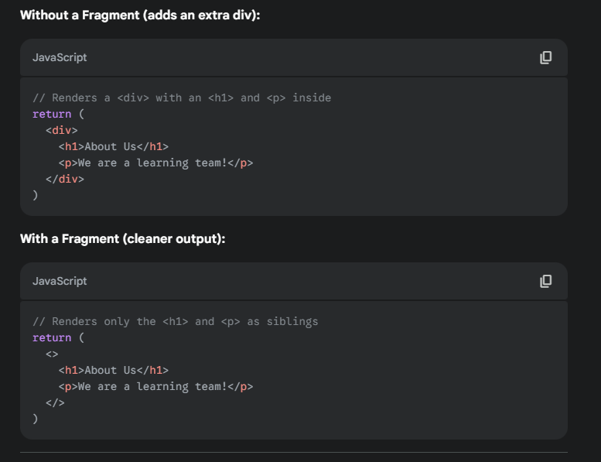
React.StrictMode
React.StrictMode is a tool for highlighting potential problems in an application. It doesn't render any visible UI but activates additional checks and warnings for its descendants. It helps you catch common mistakes and ensures you follow React best practices.
Key things StrictMode checks for:
- Identifying components with unsafe lifecycles.
- Warning about the use of legacy APIs.
- Detecting unexpected side effects by intentionally double-invoking functions.
Enabling/Disabling StrictMode
StrictMode is typically enabled by default in projects created with tools like Create React App or Vite. You enable it by wrapping your root component (or any part of your application) with the <React.StrictMode> component in your main rendering file (usually index.js or main.jsx).
To disable it, you simply remove the <React.StrictMode> tags.

Console Message Appearing Twice
This is a direct result of StrictMode's check for side effects. In development mode only, StrictMode will render your components twice to help you detect if any of your functions have unexpected side effects (i.e., they do something other than just calculating a return value). If your useEffect or other functions log to the console, you will see the message appear twice.
This behavior does not happen in the production build.

Suspense
Suspense lets you specify a loading indicator (like a spinner) while a child component in the tree is waiting for something to load. This is most commonly used for code-splitting (lazy loading components) and for fetching data with Suspense-enabled frameworks.
It allows you to declaratively "suspend" rendering until the necessary data or code is available, improving the user experience by showing a fallback UI instead of an error or a blank screen.

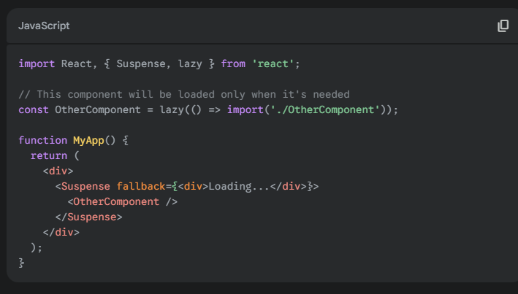
three types of dependency arrays

No Dependency Array
JavaScript
useEffect(() => {
// This effect runs after every single render.
});
When you don't provide a second argument (the dependency array) to useEffect, the effect will run after every render of the component. This is useful for effects that need to be synchronized with every state or prop change.

Empty Dependency Array ([])
JavaScript
useEffect(() => {
// This effect runs only once after the initial render.
}, []);
Passing an empty array as the second argument tells React that your effect does not depend on any values from the component's scope. As a result, it will run only once after the initial render, similar to the componentDidMount lifecycle method in class components. This is ideal for one-time setups like fetching data, setting up subscriptions, or initializing libraries.

Dependency Array with Values ([dep1, dep2])
JavaScript
useEffect(() => {
// This effect runs after the initial render,
// and whenever dep1 or dep2 changes.
}, [dep1, dep2]);
When you include values in the dependency array, the effect will run after the initial render and then only when one of the values in the array has changed between renders. This allows you to precisely control when your side effect is re-executed, which is crucial for performance and preventing unnecessary re-renders or API calls. React uses a shallow comparison to check if the values have changed.

Controlled Components
In React, a controlled component is a form element (like <input>, <textarea>, or <select>) whose value is controlled by React's state. This means the component's value is always determined by the data in your component's state, and any changes to the input must first update the state.
How it works:
- You bind the form element's value prop to a piece of state.
- You handle changes with an onChange event handler.
- The onChange handler updates the state with the new value.
- React re-renders the component, and the input's value reflects the new state.
This approach gives you instant control over the form's data. You can easily validate the input in real-time, modify the value as the user types, or conditionally enable/disable other parts of the UI.

Controlled Component Example
Imagine a login form with a username field. With a controlled component, React's state is the single source of truth for the input's value. This means that whenever the user types, the useState hook immediately updates.
n this example, the username state and the handleUsernameChange function work together to manage the input. The value={username} prop ensures that the input's displayed text always matches the state.

Uncontrolled Components
An uncontrolled component is a form element that manages its own state internally, without React's intervention. The value of the input is handled by the DOM itself.
How it works:
- You let the browser handle the input's value.
- You use a ref to access the DOM node directly.
- You read the input's value from the DOM when you need it (e.g., when the form is submitted).
This approach is simpler for basic use cases, as you don't need to write an onChange handler for every input. It's often compared to how traditional HTML forms work.

Uncontrolled Component Example
Now, let's look at the same login form as an uncontrolled component. Here, the input's value is managed by the DOM itself. We use a ref to get direct access to the DOM element and read its value only when needed (e.g., when the form is submitted).

In this case, there's no state or onChange handler for the input. The value is stored in the input element itself. When the user clicks "Login," we use usernameRef.current.value to grab the current text from the DOM.

Analogy: The Waiter and the Notepad
- Controlled Component (Waiter): You tell a waiter your order (state). If you change your mind, you tell the waiter, who updates their notepad (state) and then tells the kitchen the new order. The waiter is in full control of the order.
- Uncontrolled Component (Notepad): You write your own order on a notepad on your table (DOM). When you're ready, you give the notepad to the waiter (ref), who then takes the complete order to the kitchen. The waiter only gets the final order when you're done.

What are Refs?
In React, a ref is a way to access a DOM element or a React component instance directly. It stands for "reference." While state and props are the standard way to handle data flow and component updates, refs provide an "escape hatch" to interact with the underlying DOM when you need to perform actions that don't involve the typical data flow, like focusing an input or measuring a DOM element's size.

What is useRef?
useRef is a React Hook that lets you create a ref. It's the modern, functional component equivalent of the old React.createRef() method used in class components.
When you call useRef(), it returns a plain JavaScript object with a single property called .current. This .current property can be set to any value, but its primary purpose is to hold a reference to a DOM node.
Key characteristics of useRef:
- Persists across re-renders: Unlike regular variables that are reset on every re-render, the value of .current in a ref persists for the entire lifecycle of the component.
- Does not trigger a re-render: Changing the value of .current does not cause the component to re-render. This is a crucial difference from useState. You should not use useRef to store data that needs to be displayed in the UI.

Advantages of Refs
- Direct DOM Manipulation: Refs allow you to directly access and manipulate the underlying DOM nodes, which is essential for tasks like managing focus, text selection, media playback, or integrating with third-party DOM libraries.
- Persistent Storage: The .current property of a ref persists across renders without causing a component to re-render. This makes it an ideal "instance variable" for storing values that are needed throughout the component's lifecycle but aren't part of the UI state.
- Performance: Since changing a ref's value doesn't trigger a re-render, it can be more performant than using state for certain tasks, particularly those involving frequent updates that don't need to be reflected in the UI.

How to use useRef
The most common use case is to get a reference to a DOM element.
- Create a ref: Call useRef(null) at the top of your component. This returns the ref object.
- Attach the ref: Pass the ref object to the ref prop of the element you want to reference (e.g., <input ref={myInputRef} />). React will automatically set the myInputRef.current property to the actual DOM node when the component mounts.
- Access the DOM node: You can now access the DOM element and its properties (like .value or .focus()) via myInputRef.current.

Ref vs. forwardRef
ref
As explained, ref is a special prop you can add to a React element to get a reference to the corresponding DOM node. However, you cannot use the ref prop on a custom functional component directly because it doesn't have a DOM instance to attach to.

forwardRef
forwardRef is a React utility that solves this problem. It allows a parent component to pass a ref down to a child functional component, which then attaches the ref to one of its own DOM elements.
This is how forwardRef works:
- Wrap your child component in forwardRef().
- The component now receives a second argument: the ref from the parent.
- You pass this ref to the DOM element you want the parent to be able to access.
Storing and Changing Values in Refs
Refs are not just for ace ssing DOM elements; you can use them to store any mutable value that you want to persist across renders without causing a re-render. You can store and change values directly on the .current property of the ref object.
For example, to store a value:
JavaScript
const myRef = useRef(0);
// Store a new value in the ref
myRef.current = myRef.current + 1;
This is useful for values that you need to keep track of but don't want to trigger a re-render, such as a timer ID or a previous value of a prop.

Advantages of Refs
- Direct DOM Manipulation: Refs allow you to directly access and manipulate the underlying DOM nodes, which is essential for tasks like managing focus, text selection, media playback, or integrating with third-party DOM libraries.
- Persistent Storage: The .current property of a ref persists across renders without causing a component to re-render. This makes it an ideal "instance variable" for storing values that are needed throughout the component's lifecycle but aren't part of the UI state.
- Performance: Since changing a ref's value doesn't trigger a re-render, it can be more performant than using state for certain tasks, particularly those involving frequent updates that don't need to be reflected in the UI.

How to Access Input Data Using Ref
To access the data from an input field using a ref, you follow these steps:
- Create a ref using useRef().
- Attach the ref to the input element's ref prop.
- Access the input's value by using the .current.value property of the ref.

You can't declare a hook inside a conditional statement like an if condition because of the Rules of Hooks. React relies on the call order of hooks to be consistent on every render. If you were to place a hook inside an if statement, it might not be called on every render, which would break this consistent order and lead to unpredictable behavior and bugs.

CamelCase Naming for Components
Components must have their names begin with a capital letter (PascalCase or CamelCase) to distinguish them from regular HTML tags. When React sees a tag like <div /> it treats it as a standard HTML element. However, when it sees a tag like <MyComponent />, it recognizes it as a React component and knows to render it using your custom logic.

Single Parent Requirement
A component must return a single root element (a single parent) because React's render function needs to return a single JavaScript object that represents the UI tree. If you try to return multiple elements, React wouldn't know how to represent them in a single tree structure. The single parent acts as the root of the component's output, allowing React to efficiently manage the component's DOM representation. You can use a <div> or a React fragment (<></>) to wrap multiple child elements into a single parent.

